­­­Experimental Report - SKYDAR

**Introduction**

Experimenting SKYDAR positioning and motor rotation accuracy. Measuring distance and time it takes to complete the survey.

**Test 1** – Indoor experiment – 8/3

5 sets data

Distance Travel = 2.83464 m

Time It Take To Complete Survey

|  |  |  |  |
| --- | --- | --- | --- |
| Initial | Final | Total Time (m:s) | Total Time (s) |
| 04:03:20 | 04:04:59 | ﻿01:39 | 99 |
| 04:05:15 | 04:06:54 | ﻿01:39 | 99 |
| 04:07:15 | 04:08:54 | 01:39 | 99 |
| 04:09:50 | 04:06:54 | 01:39 | 99 |
| 04:12:01 | 04:13:39 | 01:38 | 98 |

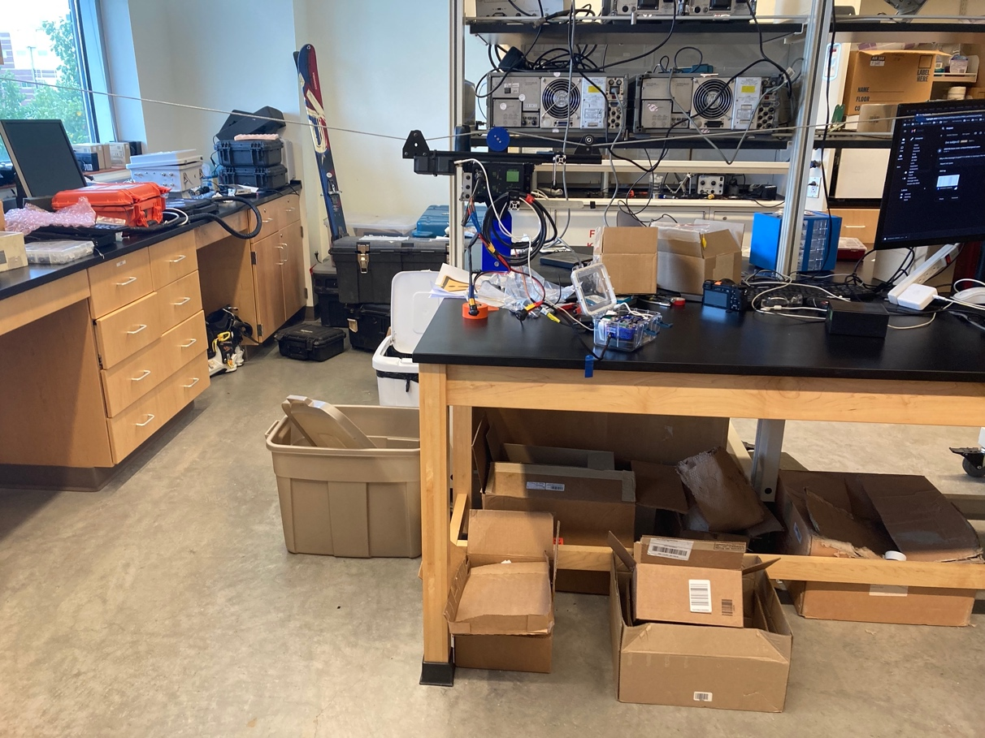

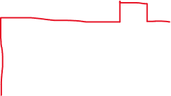

﻿

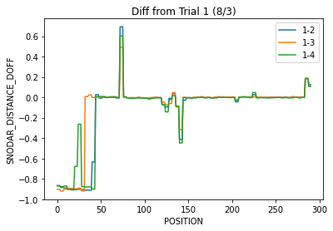

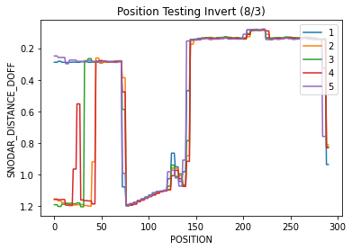

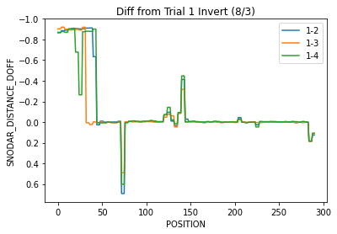

**Test 2** – Indoor experiment – 8/5

5 sets data

Distance Travel ~ 2.83 m

\***Clear survey sight**

Time It Take To Complete Survey

|  |  |  |  |
| --- | --- | --- | --- |
| Initial | Final | Total Time (m:s) | Total Time (s) |
| ﻿03:12:39 | ﻿03:14:17 | ﻿01:38 | 98 |
| ﻿03:14:55 | ﻿03:16:33 | ﻿01:38 | 98 |
| ﻿03:16:57 | ﻿03:18:35 | 01:38 | 98 |
| ﻿03:18:56 | ﻿03:20:34 | 01:38 | 98 |
| ﻿03:21:01 | ﻿03:22:40 | 01:39 | 99 |



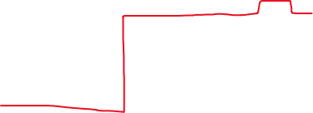

Moving window average

Histogram ?

This data set looks pretty good in term of repetition.

**Test 3** – Outdoor experiment – 8/5

5 sets data

Distance Travel ~ 2.83*3 m

Time It Take To Complete Survey

|  |  |  |  |
| --- | --- | --- | --- |
| Initial | Final | Total Time (m:s) | Total Time (s) |
| ﻿05:06:00 | ﻿05:10:46 | ﻿04:46 | 286 |
| ﻿05:11:20 | ﻿05:16:06 | ﻿04:46 | 286 |
| ﻿05:16:28 | ﻿05:21:14 | 04:46 | 286 |
| ﻿05:21:36 | ﻿05:26:21 | 04:45 | 285 |
| ﻿05:26:38 | ﻿05:31:23 | 04:45 | 285 |

**Test 4** – Outdoor experiment – 8/8

5 sets data

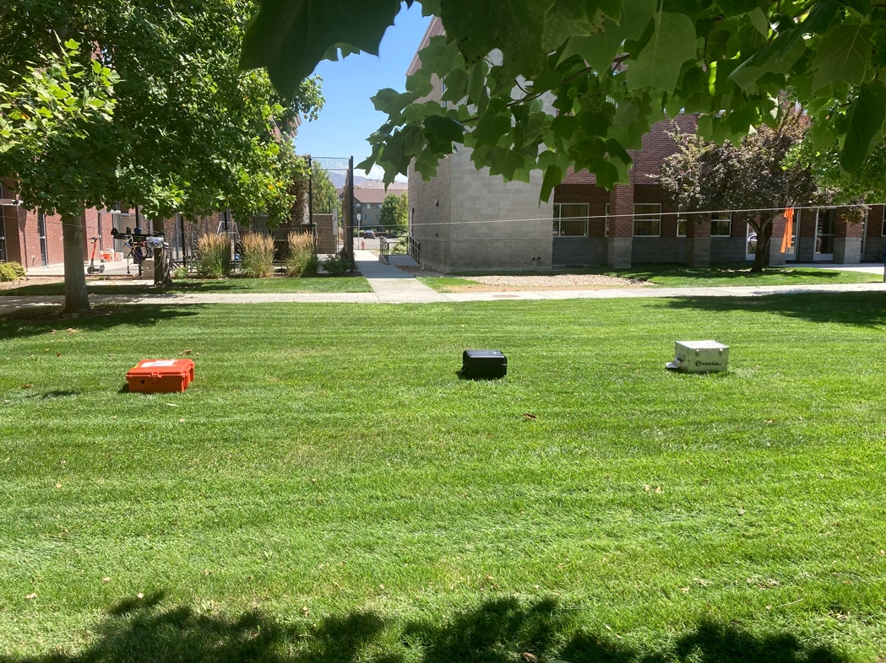

Because the lidar is incapable of capturing measurement within 1 sec, I decided to fill in the missing measurement displaying with zero and using interpolation.

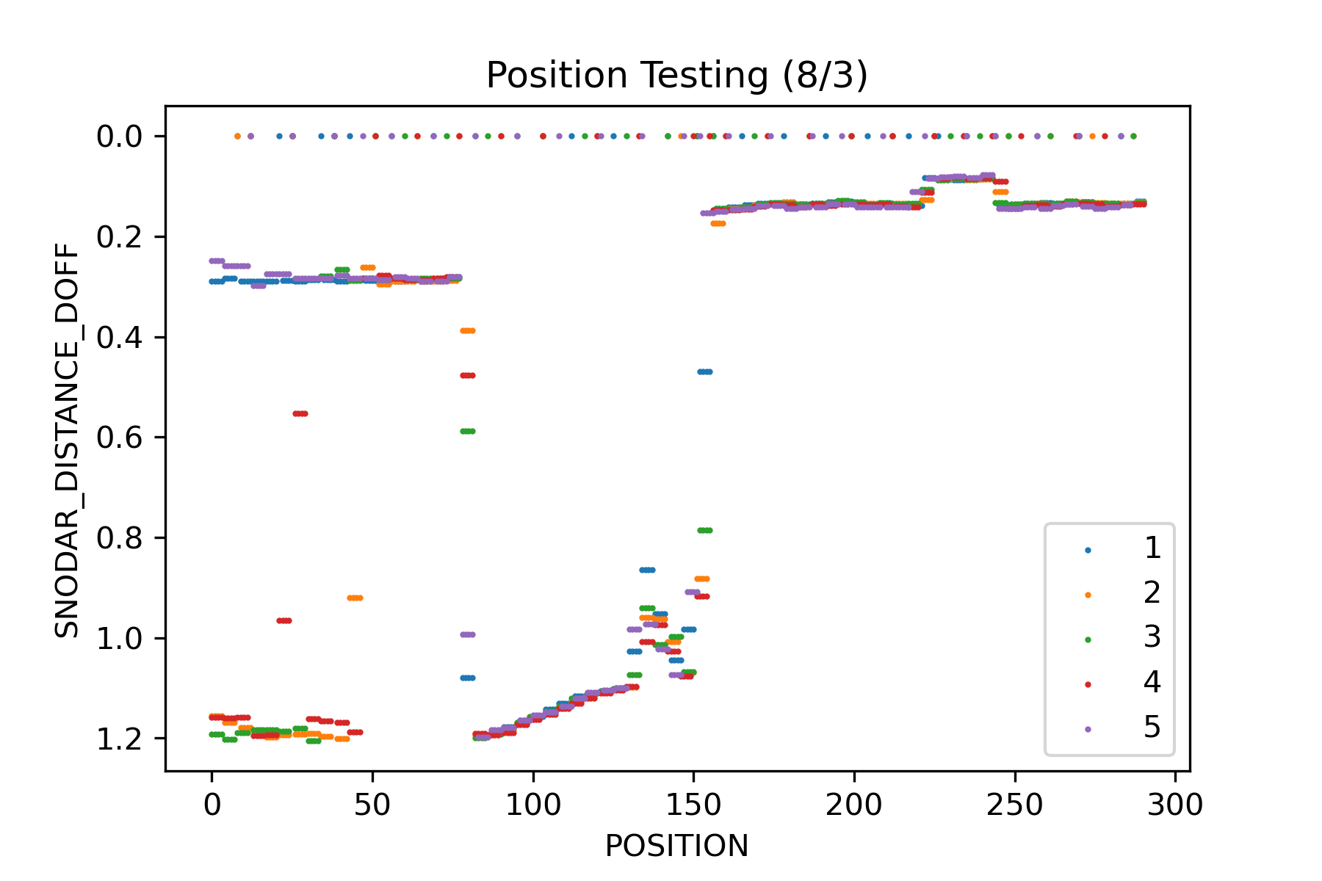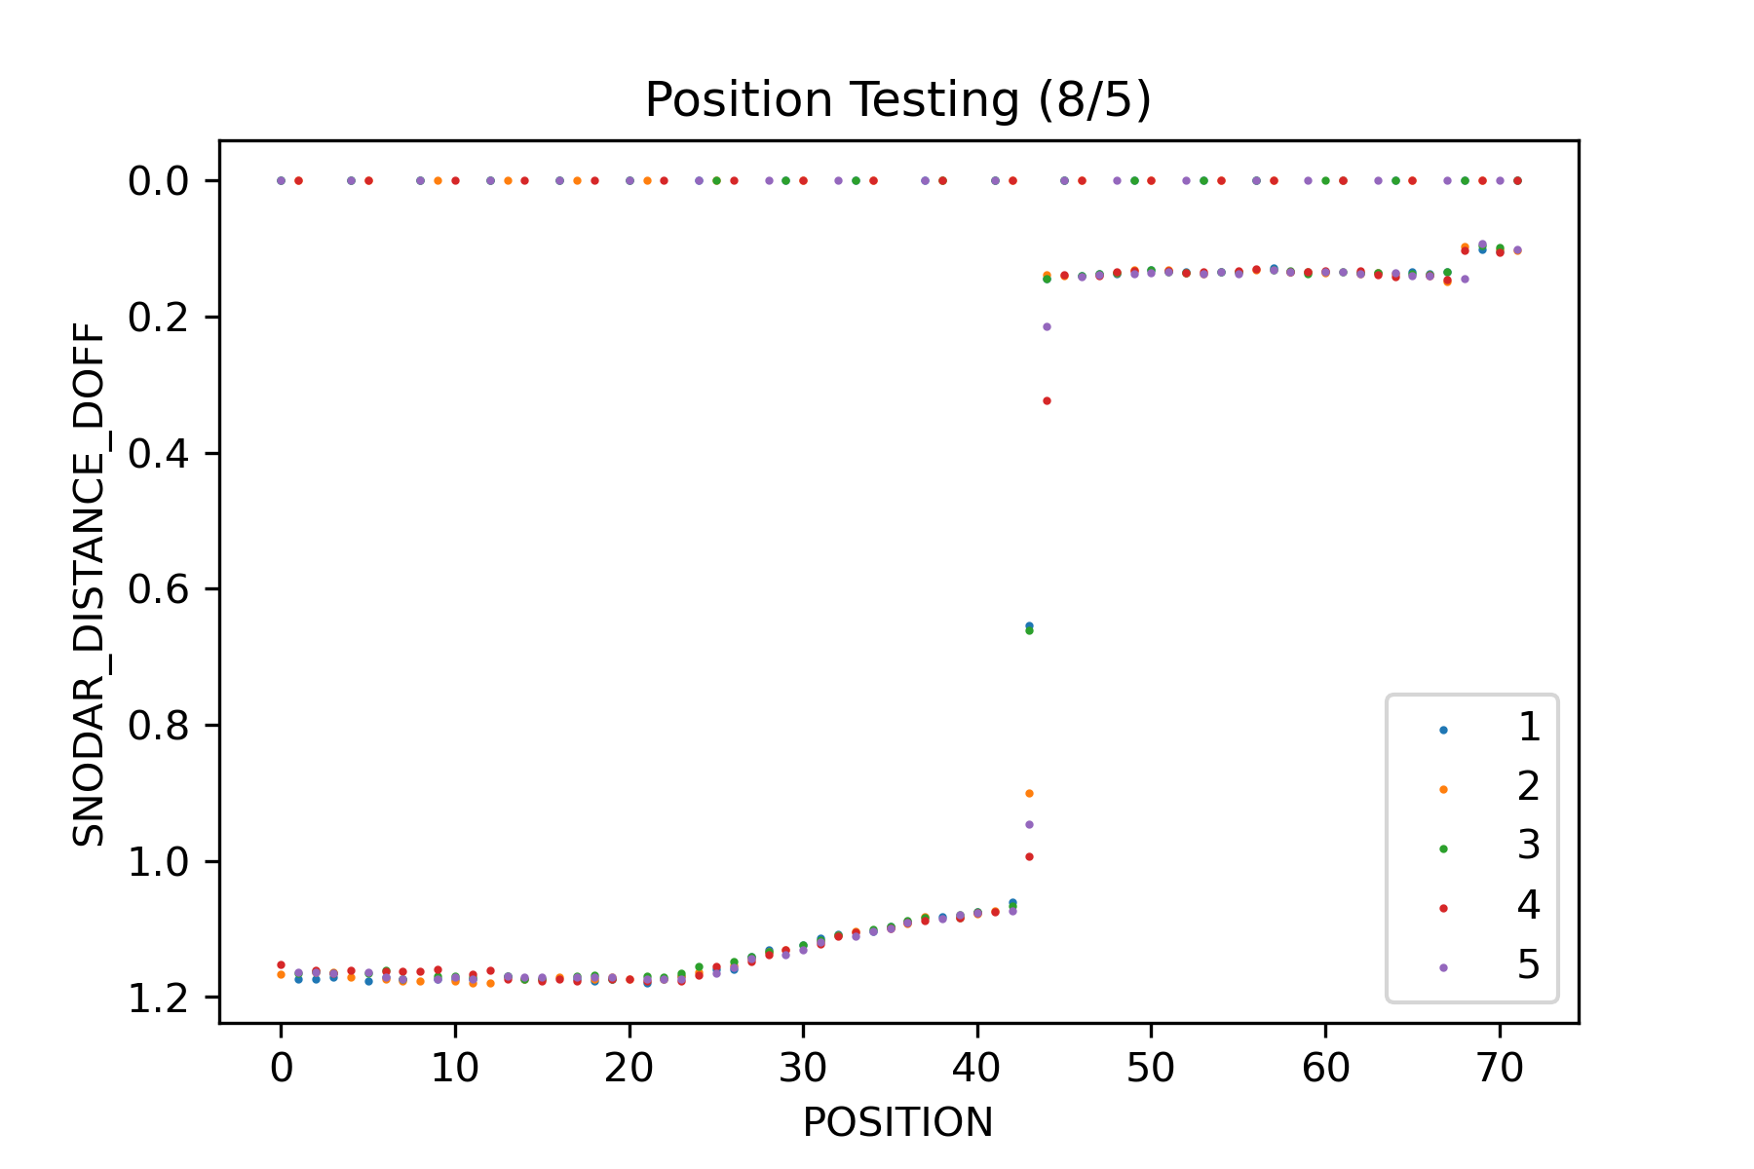

Interpolation with correct x-axis

New Test with longer delay on motor

*Shift position

T1

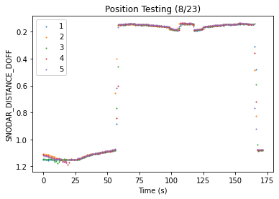

T2

New rotation wheel (TPU overture brand) + outdoor test

